Press Release Contact November 19, 2021 +97699013322

AmCham Mongolia discussed priorities for 2022

ULAANBAATAR, Mongolia - The American Chamber of Commerce in Mongolia (AmCham Mongolia) held its Annual General Meeting 2021 on November 19, 2021. The virtual meeting was attended by around 50 AmCham members and the foreign embassy representatives. The meeting began with AmCham Mongolia Chairman Jay Liotta’s opening remarks, followed by the keynote statement by H.E. U.S. Ambassador to Mongolia Michael S. Klecheski and a presentation by AmCham Mongolia Executive Director Adiya Oyungerel.
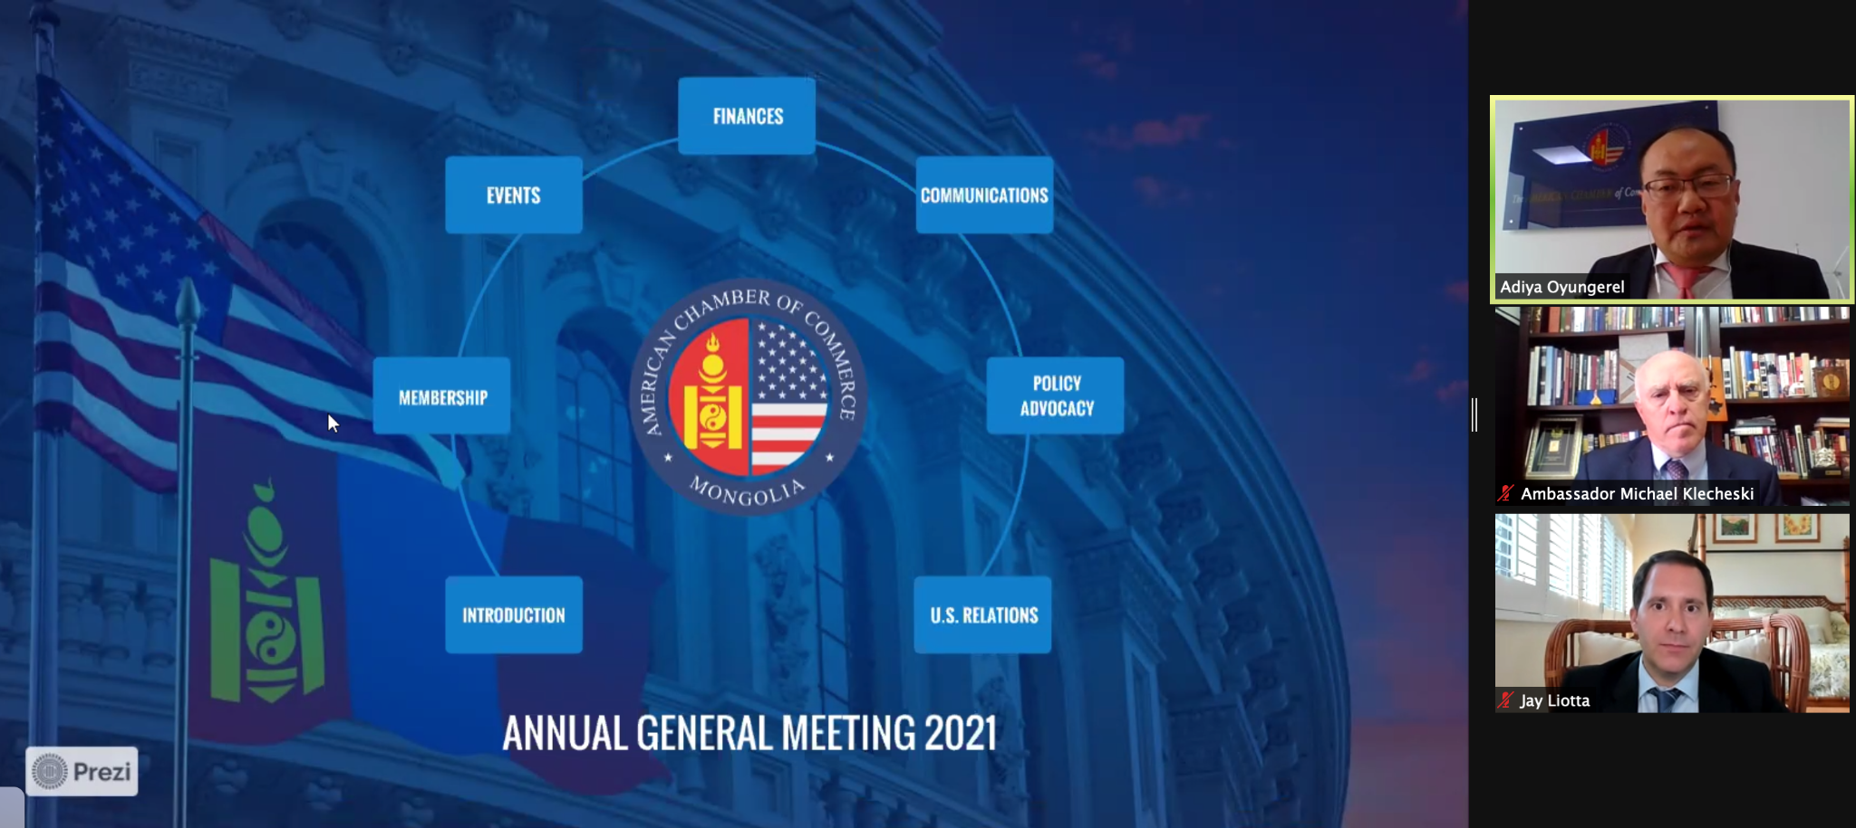
The newly appointed Directors of the Board are Gary Biondo, chairman of the International School of Ulaanbaatar, and Matthew Metz, Vice President Industrial of MSM Group.
In his opening remarks, AmCham Chairman Jay Liotta stated, “This year continued to be a challenge. We saw soaring COVID cases in Mongolia, and globally; business is not back to normal, we face border issues, flight and travel restrictions, health and safety issues, inflation, and a struggling economy and business environment.
“Yet, AmCham made unprecedented progress in 2021, some of the greatest progress in our 10-year history. We have achieved engagement; 2021 marks a record year for the Government of Mongolia and other chambers contacting AmCham to ask for our leadership, guidance, and participation. As we set course for next year, we will continue to serve you by increasing your profile and the profile of our organization, focusing our engagements and advocacy to become more effective, speaking loudly as a voice for a level playing field for businesses, and a private sector-driven free market economy in Mongolia, and much more. ”

In his remarks, Ambassador Klecheski said, “AmCham has done an incredible job engaging with the government on laws and regulations, CSR through mentor day, improving things large and small. AmCham has become a nexus point for training the next generation of business leaders, not only in how to do business profitably but ethically and sustainably teaching how business plays in a community. We will continue to support AmCham and the business community.
In terms of the investment climate we have not seen improvements necessary to motivate investment, foreign or domestic. As reported in the Mongolia 2021 Mongolia investment climate statement, the investment and business climate really is cripled by unpredictable, sometimes corrupt applications of laws and regulations and this makes Mongolia a less competitive destination for investors.``
AmCham Mongolia’s Executive Director, Adiya Oyungerel, presented the 2021 Annual Report and 2022 Workplan. He stated, “This year marks the 10th anniversary of AmCham. We congratulate and thank our board members and member organizations for their leadership and support throughout the years. In 2022 AmCham Mongolia will undertake more policy actions to support the members and to initiate actions to address climate change, and to create the level playing field for the American businesses and our members, Next year we also plan to continue building partnerships with the peer AmChams in the Indo-Pacific region and the U.S.-based stakeholders.”

About AmCham Mongolia
The American Chamber of Commerce (AmCham) in Mongolia is an independent membership-driven organization that seeks to build, strengthen, and protect business between the United States and Mongolia, and to actively promote Mongolia as a destination for American investment. AmCham Mongolia is accredited by the U.S. Chamber of Commerce as its official affiliate in Mongolia. Based in Washington D.C., the U.S. Chamber of Commerce is the largest federation in the world with over 3 million members.

