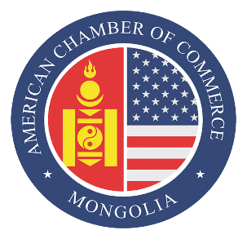
Press Release Contact
08.11.2021 +97699013322

AmCham Mongolia hosts Mongolia 2022: What’s Next?

ULAANBAATAR, Mongolia – The American Chamber of Commerce in Mongolia’s Financial Services Committee organized a meeting on the topic of “Mongolia 2022: What’s Next?” and discussed the urgent need for budget reforms aimed at structural improvements.

The panelists for the event were independent economist N. Enkhbayar and Resident Representative of the International Monetary Fund (IMF) for Mongolia SeokHyun Yoon.

The meeting was well attended by over 70 people, including representatives of the AmCham community, foreign and domestic investors, and SMEs.
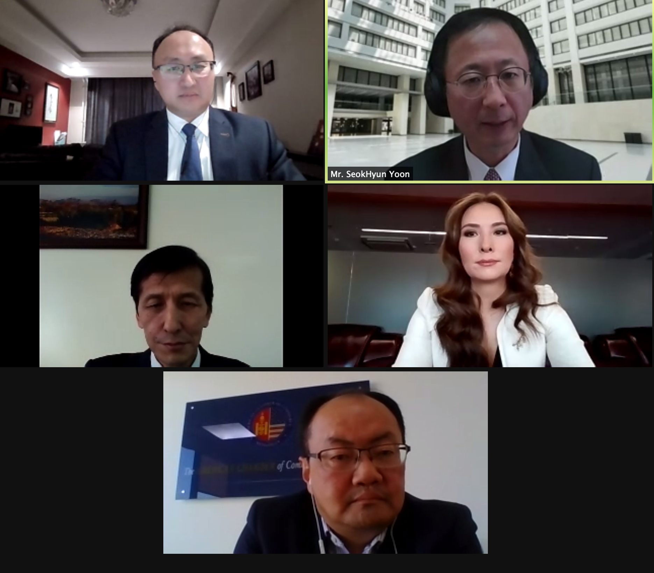
In her opening remarks, Munkhnasan Narmandakh, vice chairwoman of AmCham’s Board of Directors, stated, “Mongolia’s economy has been hit by the COVID-19 crisis and we’ve been experiencing the worst contraction since the economic transition in the early 1990s. But [the economy] was projected to rebound in 2021, and we will see how the final numbers will turn out at the end of the year. We had a 7.3 percent decline in the first nine months of 2020. The World Bank’s latest Mongolia Economic Update estimated that the economy would grow by 4.3 percent in 2021, but we have many challenges due to the border closure; we are facing even more uncertainties. The COVID-19 shock to the Mongolian economy has been severe and widespread, affecting the conditions of neighboring markets. Employment has increased in the IT and health sectors, as jobs declined in other sectors. ADB recommends that Mongolia accelerate structural reforms, strengthening financial stability to increase growth.”

Mr. SeokHyun Yoon gave a presentation on the immediate challenges and risks surrounding Mongolia. One starting point is the Asia and Pacific: Regional Economic Outlook, an IMF publication presented during annual meetings which took place three weeks ago. 2020 was a particularly difficult year, with global growth at -3.1 percent and Asia at -1.3 percent. Even though the pandemic is being contained and economies have been rebounding in 2021, the IMF expects this year for the global economic growth to reach 5.9 percent, Asia 6.5 percent, and China 8 percent. However, compared to the World Economic Outlook published six months ago, the growth prospect has decreased. There’s been a slower than expected recovery, and a faster recovery is projected in 2022. Next year, global growth is expected to reach 4.9 percent and 5.7 percent in Asia. Mongolian growth was -5.3 percent last year; this year, 5 percent growth was initially expected, however, as vaccine administration has been excellent, based on the October World Economic Outlook, 5.2 percent growth is expected. Now Mongolia is facing some challenges related to the border closure. Recently, the IMF assessed Mongolia’s economic growth this year to be 4.5% and 7.5% in the next. Given the current situation with the border closure and the Winter Olympic Games, lower projections could be expected next year.

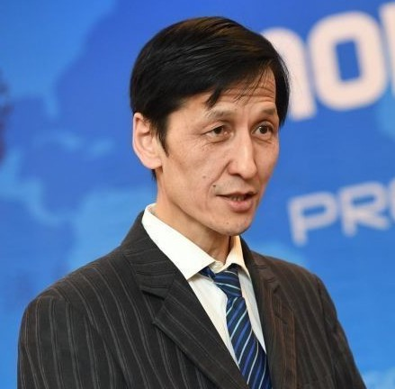
Mr. N. Enkhbayar noted that while we are in the midst of a pandemic, “Dutch disease” has been with us since 2010. The International Monetary Fund and the World Bank have repeatedly advised that Mongolia follow the Chilean economic model. The Fiscal Stability Law was passed, a fiscal framework statement was issued, and the Fiscal Stability Council was established, and steps have been taken to keep the state budget as stable as possible, but we have not been able to avoid the current economic situation. The Mongolian government has said for three years that it would raise coal exports to 42 million tons.

As of the first ten months of the year, Mongolia has exported 13.4 million tons of coal, and exports are expected to reach 16 million tons by the end of the year. This is only 45 percent of the export target. N. Enkhbayar noted that this shows us that the policy-making system of our state administration is flawed. Researchers talk about making decisions based on research, but this is not the case for our government. Recently, at the international level, there has been increased talk of making policy decisions based on data and research.

N. Enkhbayar stated, “Based on this data, exporting 42 million tons of coal is not feasible at all, and I am very disappointed with the current budget which is to be approved by Parliament. Significant numbers in this document are far from realistic. With a budget deficit projected at 5.1 percent, it is clear that at least nearly two trillion will be lost on the revenue side. If the budget deficit is approved, it will be almost 6-7 percent this year, not 5 percent. Currently, there are no conditions for improvement next year. On the contrary, there are likely to be more problems with our coal exports. For example, the railway to be commissioned in 2022; many technical issues still have not been resolved. In addition, the Tavan Tolgoi Gashuun Sukhait Railway is being built without any crossings. Secondly, this is an emerging challenge in our coal market. Russia is entering this market strongly by constructing a second line of the coal railway, which is scheduled to operate and run within two years.

“Therefore, by 2024, Russia's coal growth is likely to increase by 30-40 percent. So, we have a big competitor in coal exports. Realistically, Mongolia's coal export capacity is 20-25 million tons. Therefore, next year, Parliament needs to adopt structural policy reforms that follow the examples set by other countries.”

The discussion was followed by a Q&A session.

About AmCham Mongolia
The American Chamber of Commerce (AmCham) in Mongolia is an independent membership-driven organization that seeks to build, strengthen, and protect business between the United States and Mongolia, and to actively promote Mongolia as a destination for American investment. AmCham Mongolia is accredited by the U.S. Chamber of Commerce as its official affiliate in Mongolia. Based in Washington, D.C., the U.S. Chamber of Commerce is the largest federation in the world with over 3 million members.

